**Cloud Computing Lab**

**Nayab Khazin**

**BSE-V B**

**2023-BSE-046**

**LAB 05**

**Task 1 - Discover missing command & install Java using apt suggestion**

* task1_java_suggestion.png

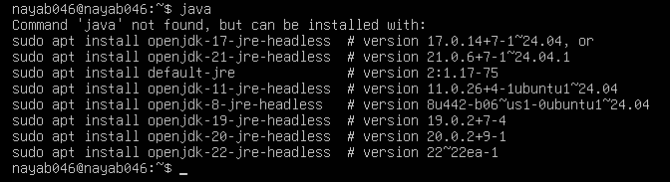

* task1_java_install.png

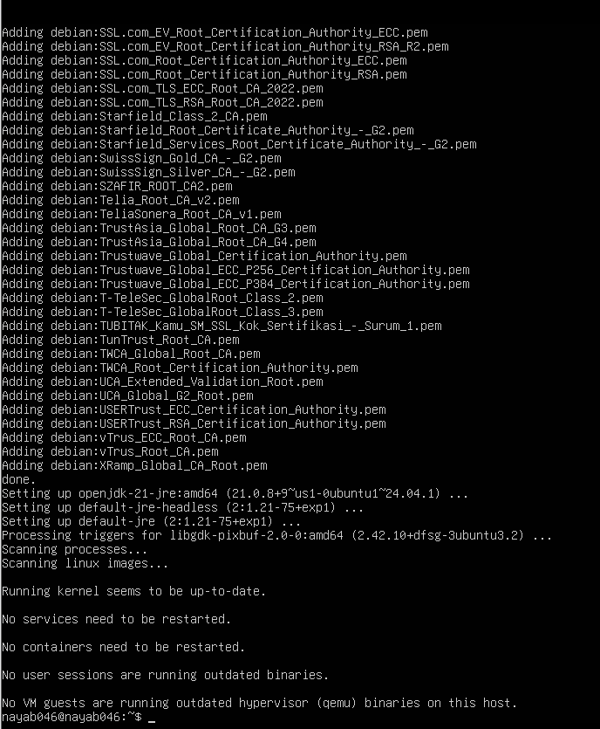

* task1_java_version.png

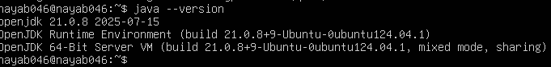

* task1_java_remove.png

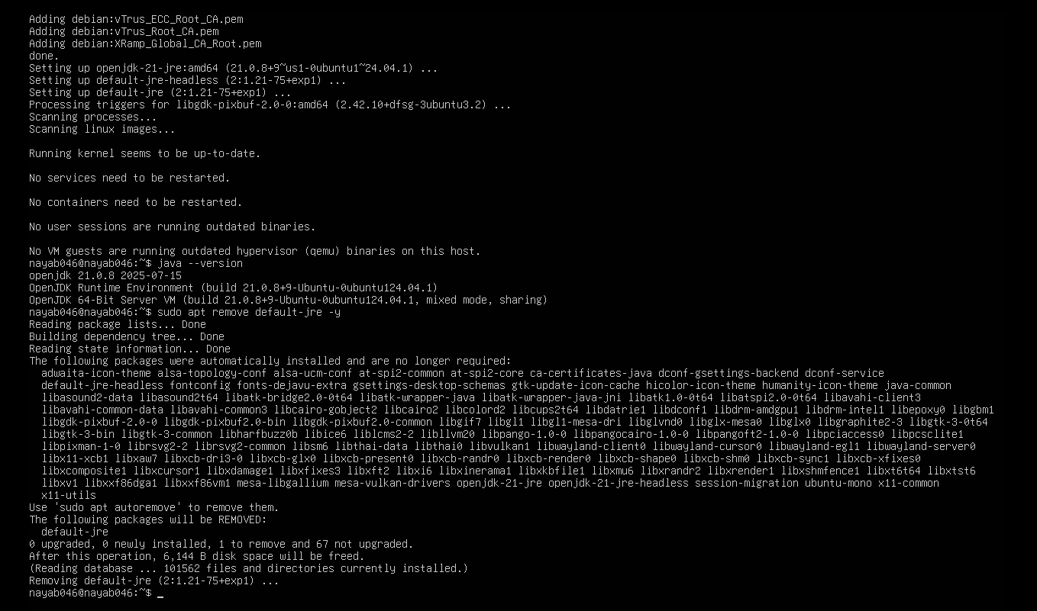

* task1_java_not_found.png

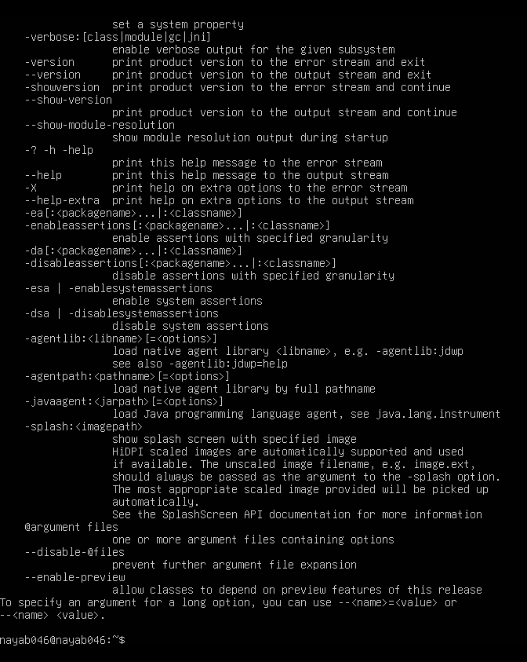

* task1_hash_clear.png

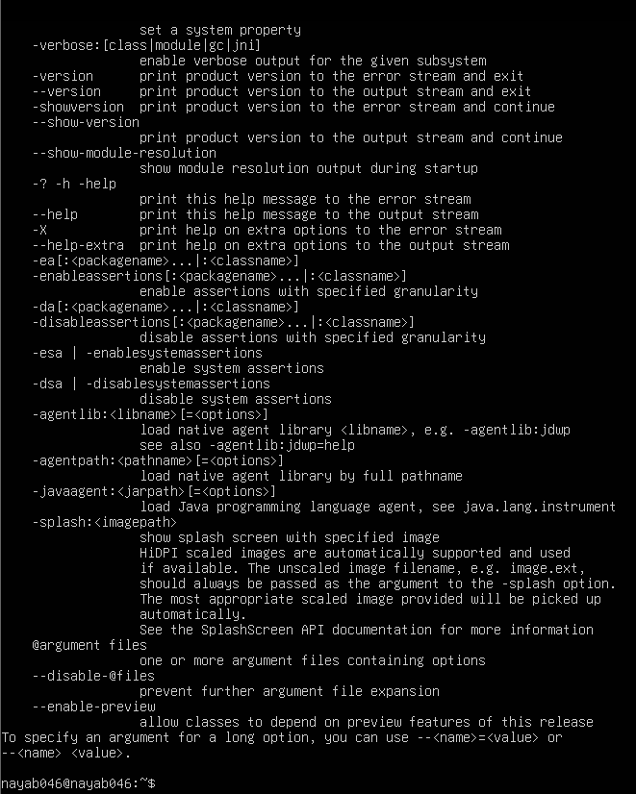

## Task 2 - Install & remove Java using apt-get (explicitly)

* task2_aptget_install.png

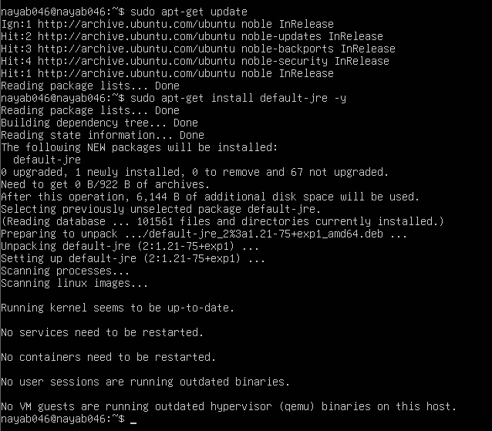

* task2_java_version_after_aptget.png

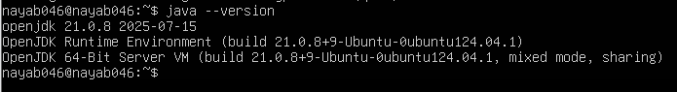

* task2_aptget_remove.png

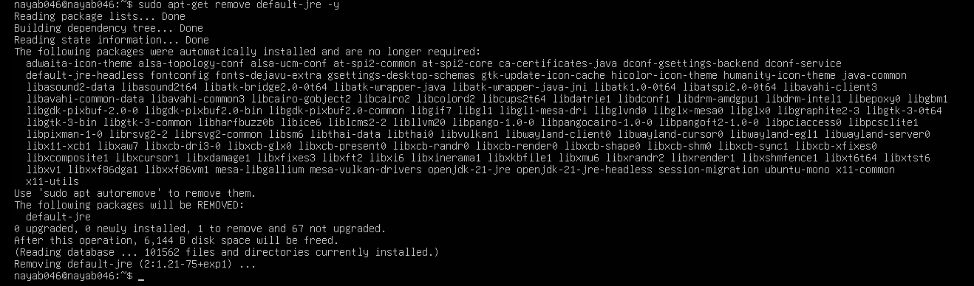

* task2_hash_after_remove.png

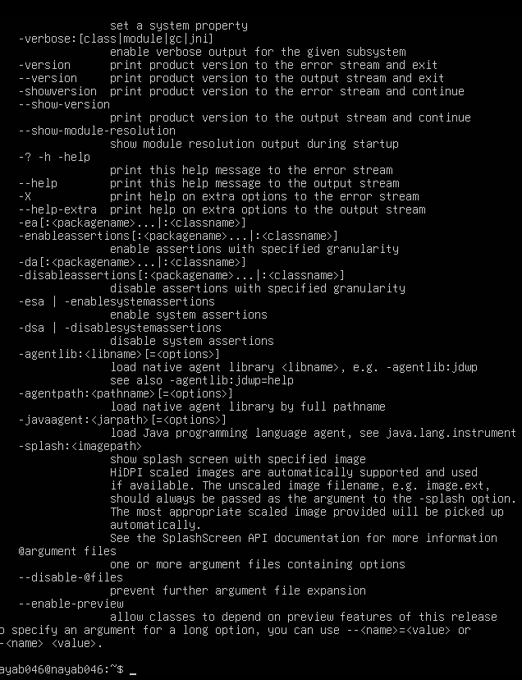

## Task 3 - apt update vs apt upgrade - run & explain

* task3_apt_update.png

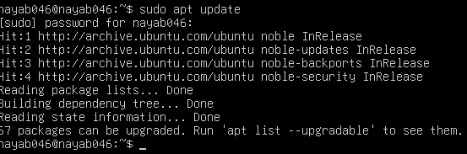

* task3_apt_upgrade.png

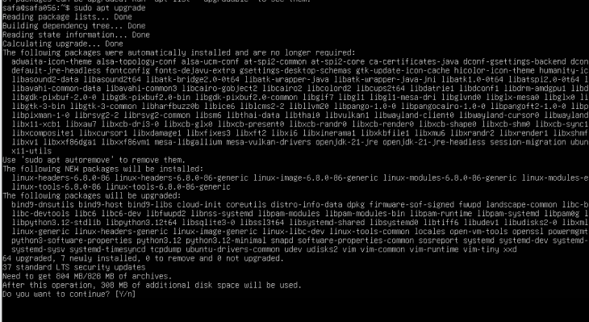

task3_explanation.png

## Task 4 - Install Visual Studio Code via snap on CLI and verify (DO NOT remove Code)

* task4_snap_install.png

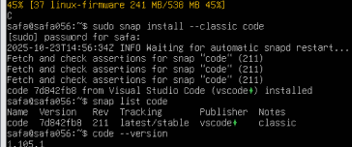

* task4_snap_list.png



* task4_code_version_or_info.png

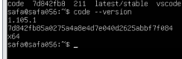

* task4_snap_bin_location.png

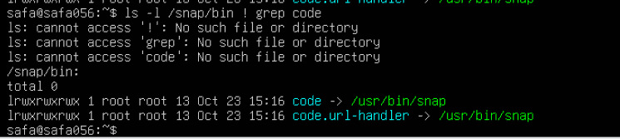

## Task 5 - Install XFCE GUI + XRDP - minimal desktop and remote access (GUI) and launch VS Code

* task5_update.png

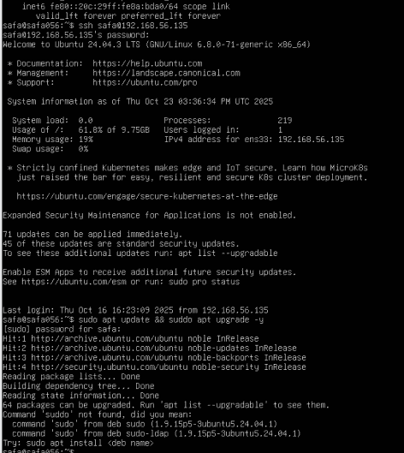

* task5_xfce_install.pn

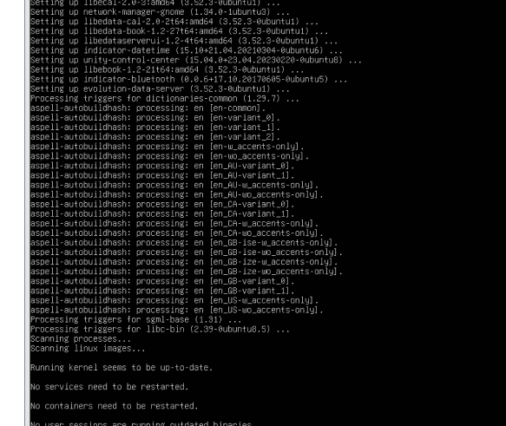

* task5_xrdp_enable.png

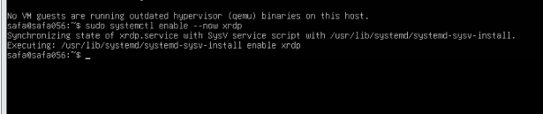

* task5_xrdp_status.png

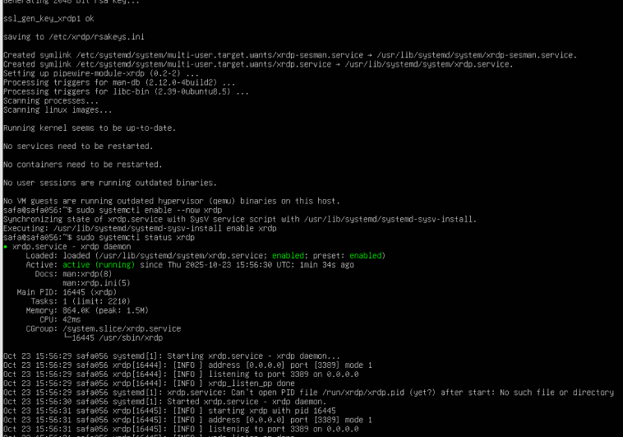

* task5_rdp_connect.png

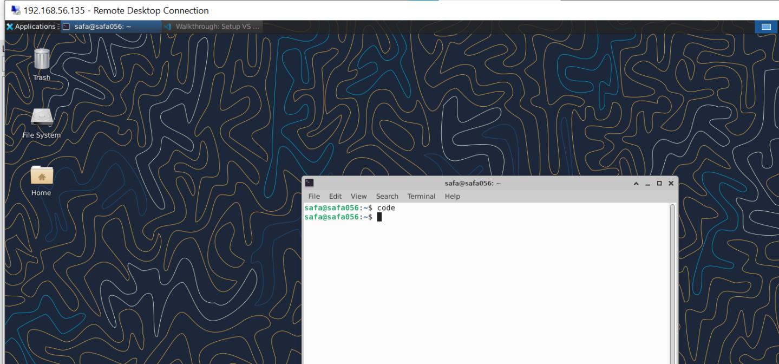

* task5_vscode_launch.png

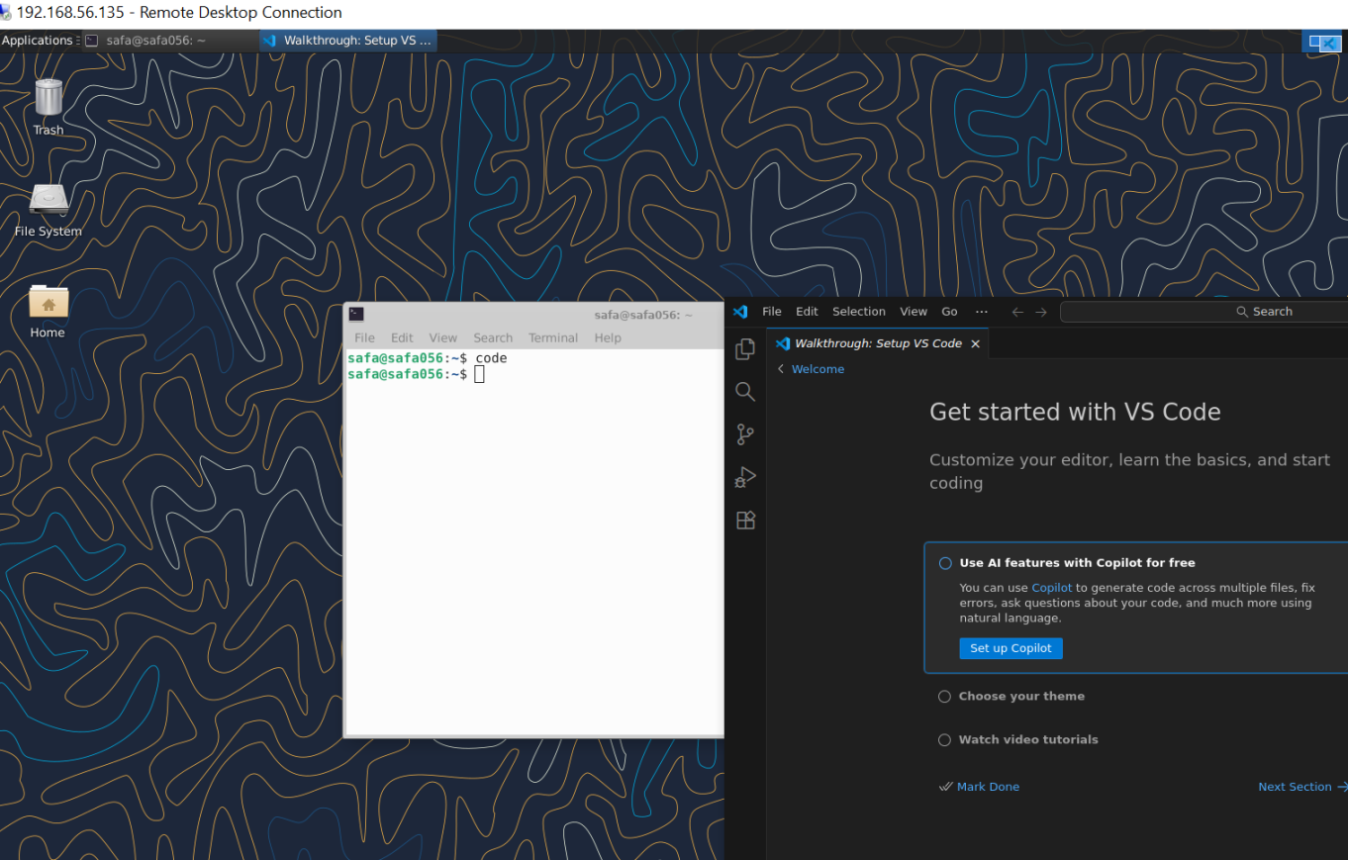

## Task 6 - Install lightdm-gtk-greeter and GUI verification - start GUI, open VS Code, take snapshot, then end (GUI)

* task6_lightdm_install.png

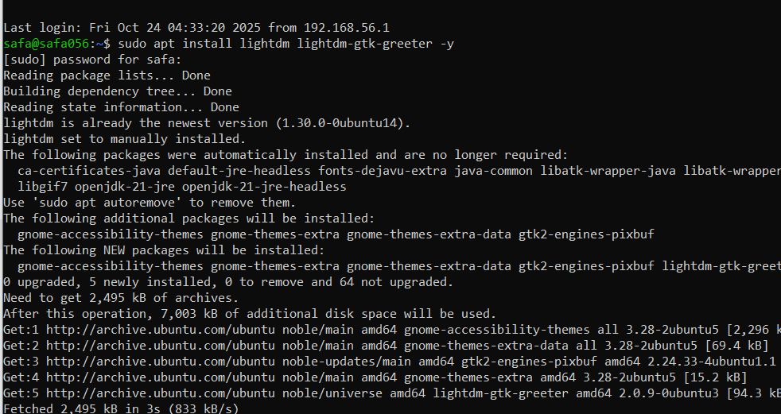

* task6_lightdm_config.png

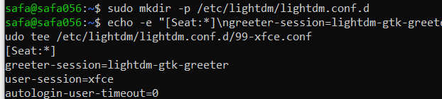

* task6_lightdm_cleanup.png

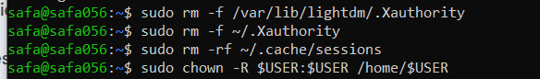

* task6_lightdm_restart.png



* task6_gui_enable_boot.png

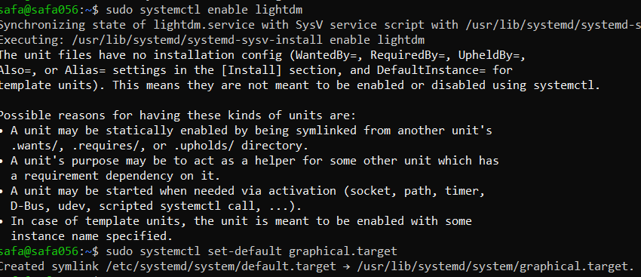

* task6_after_reboot_gui.png

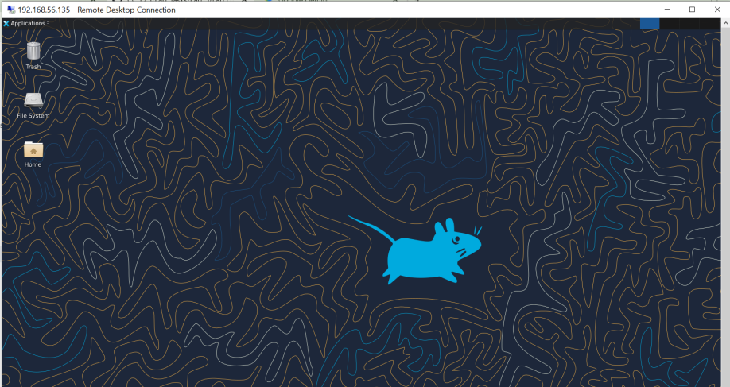

* task6_gui_disable_boot.png

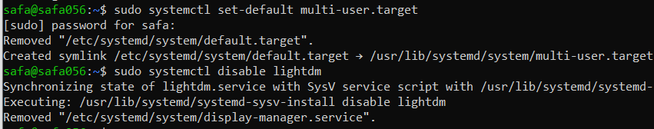

* task6_after_reboot_cli.png

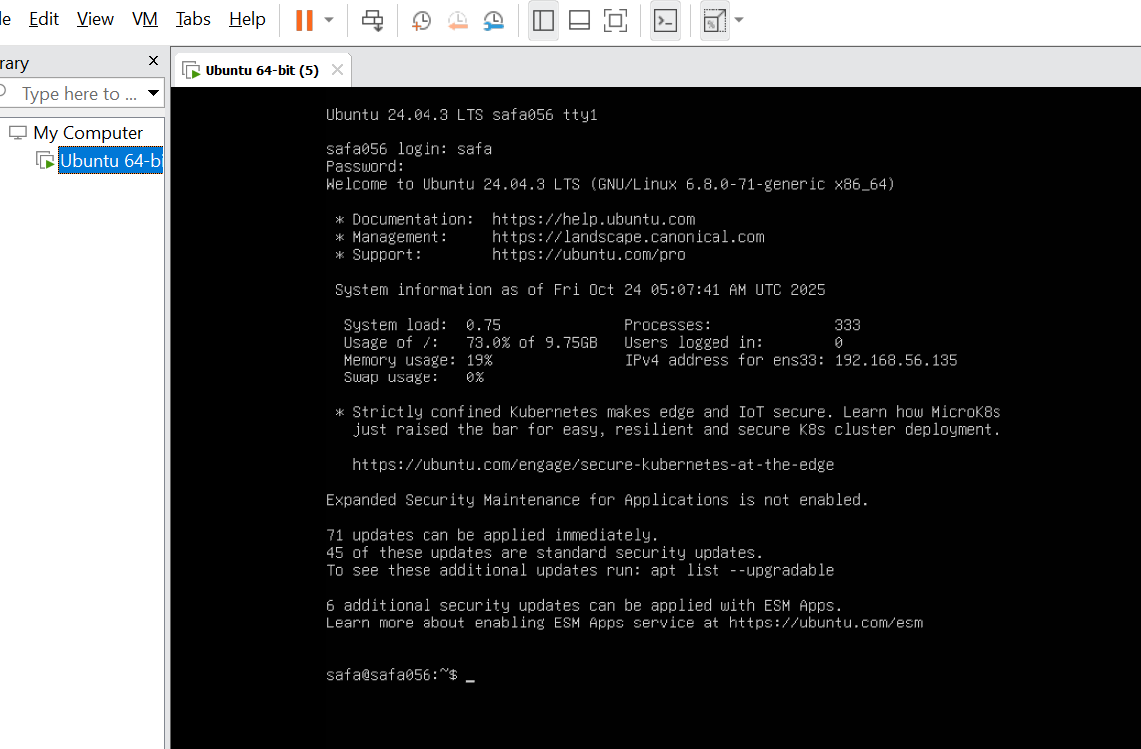

* task6_gui_stop.png

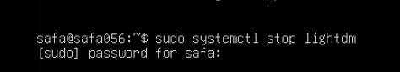

* task6_gui_start_command.png

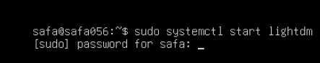

* task6_vscode_launch.png

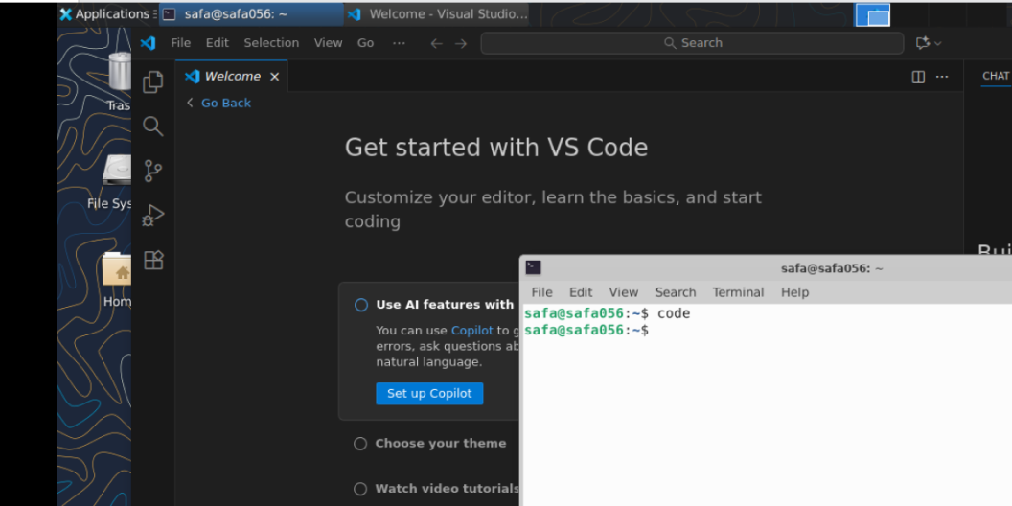

## Task 7 - Install Google Chrome by adding its apt source & key (Chrome)

* task7_install_chrome_error.png

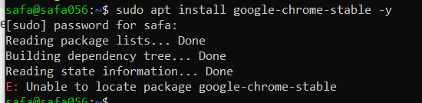

* task7_ls_etc_apt.png

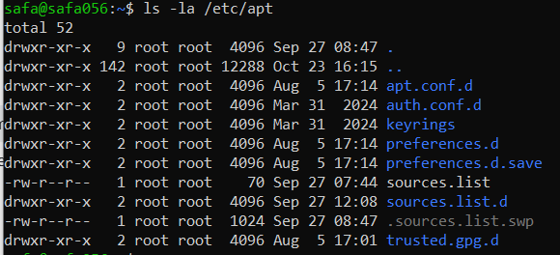

* task7_cat_sources_list.png



* task7_ls_sources_list_d.png

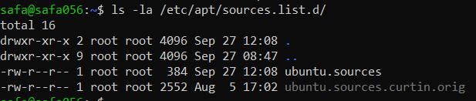

* task7_cat_ubuntu_sources.png

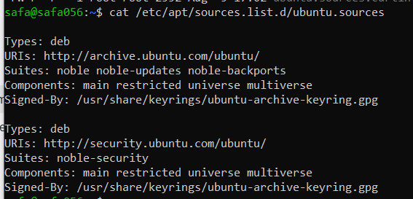

* task7_edit_ubuntu_sources.png

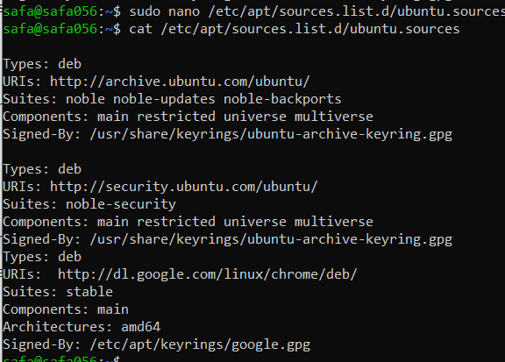

* task7_add_key.png



* task7_apt_update.png

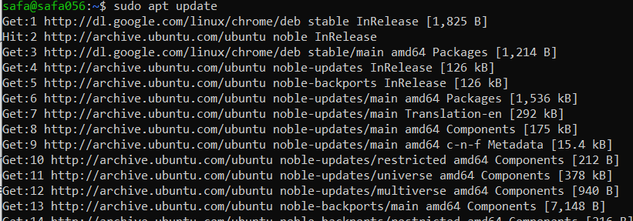

* task7_install_chrome.png

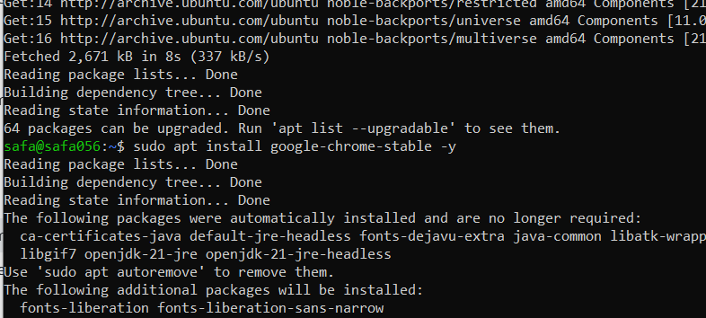

* task7_alternate_remove.png



* task7_alternate_edit.png

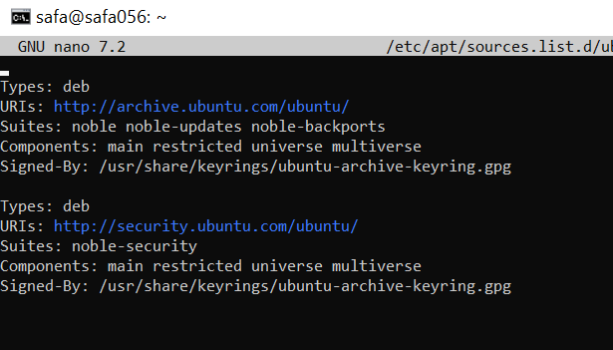

* task7_remove_key.png



* task7_create_google_chrome_list.png



* task7_list_sources_after_create.png

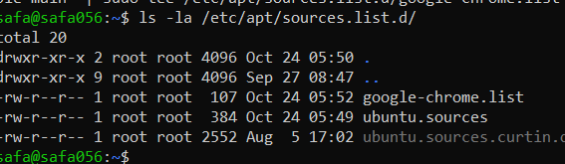

* task7_add_key_alt.png



* task7_apt_update_alt.png



* task7_install_chrome_alt.png

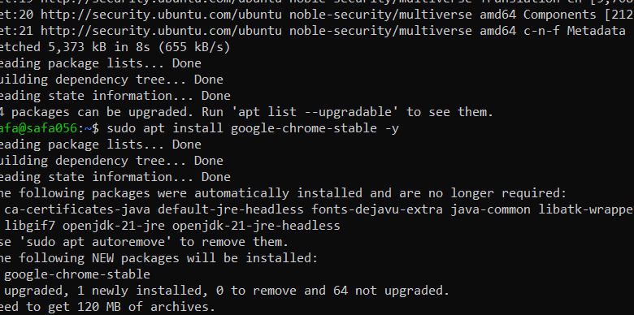

## Task 8 - Install applications via PPA (Audacity & OBS) and launch

* task8_add_ppa_audacity.png

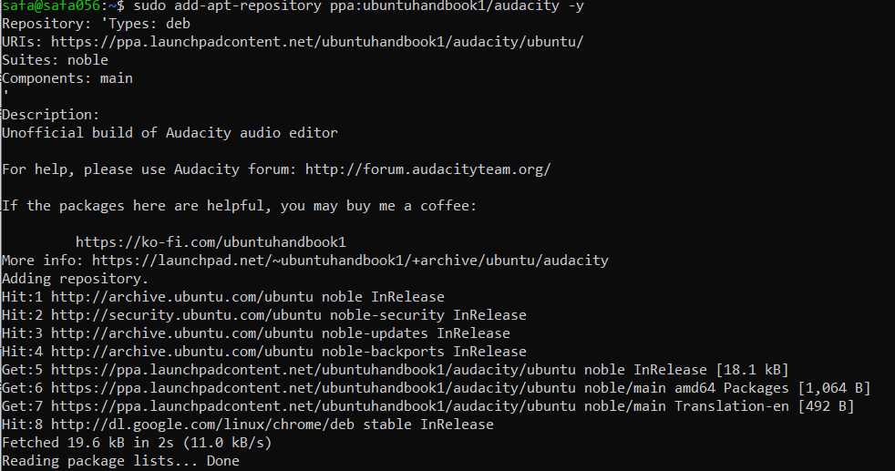

* task8_apt_update_audacity.png

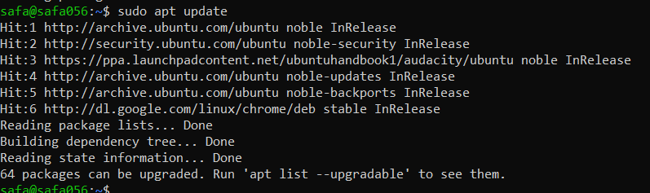

* task8_install_audacity.png

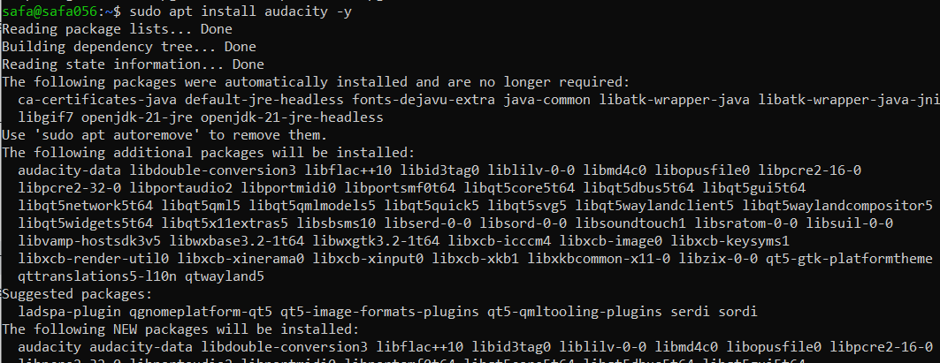

* task8_audacity_launch.png or task8_audacity_version.png

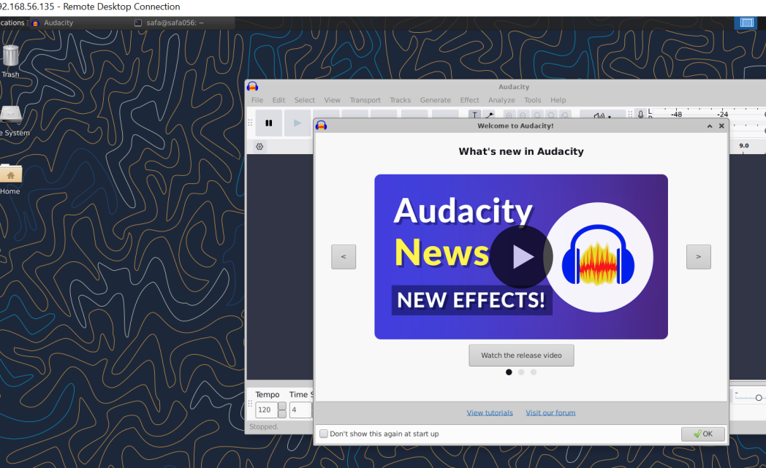

* task8_add_ppa_obs.png

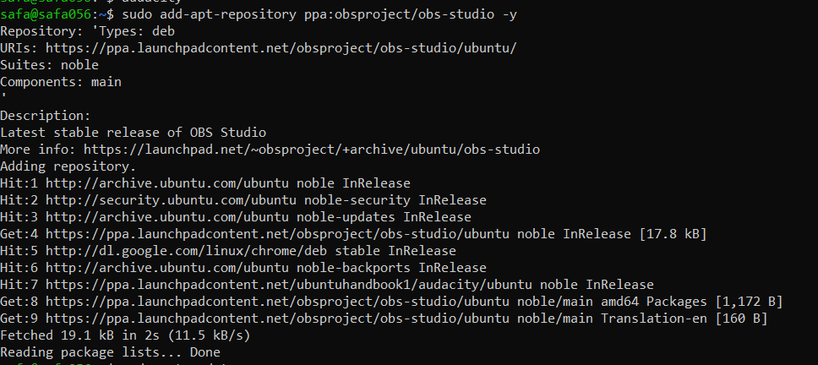

* task8_apt_update_obs.png

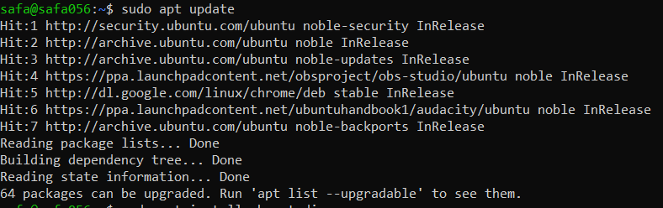

* task8_install_obs.png

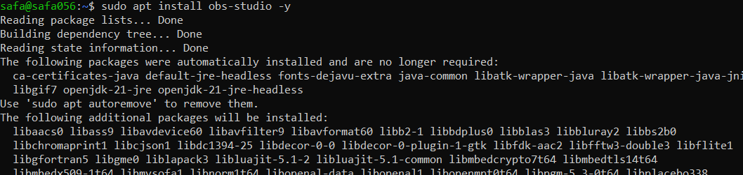

* task8_obs_launch.png or task8_obs_version.png

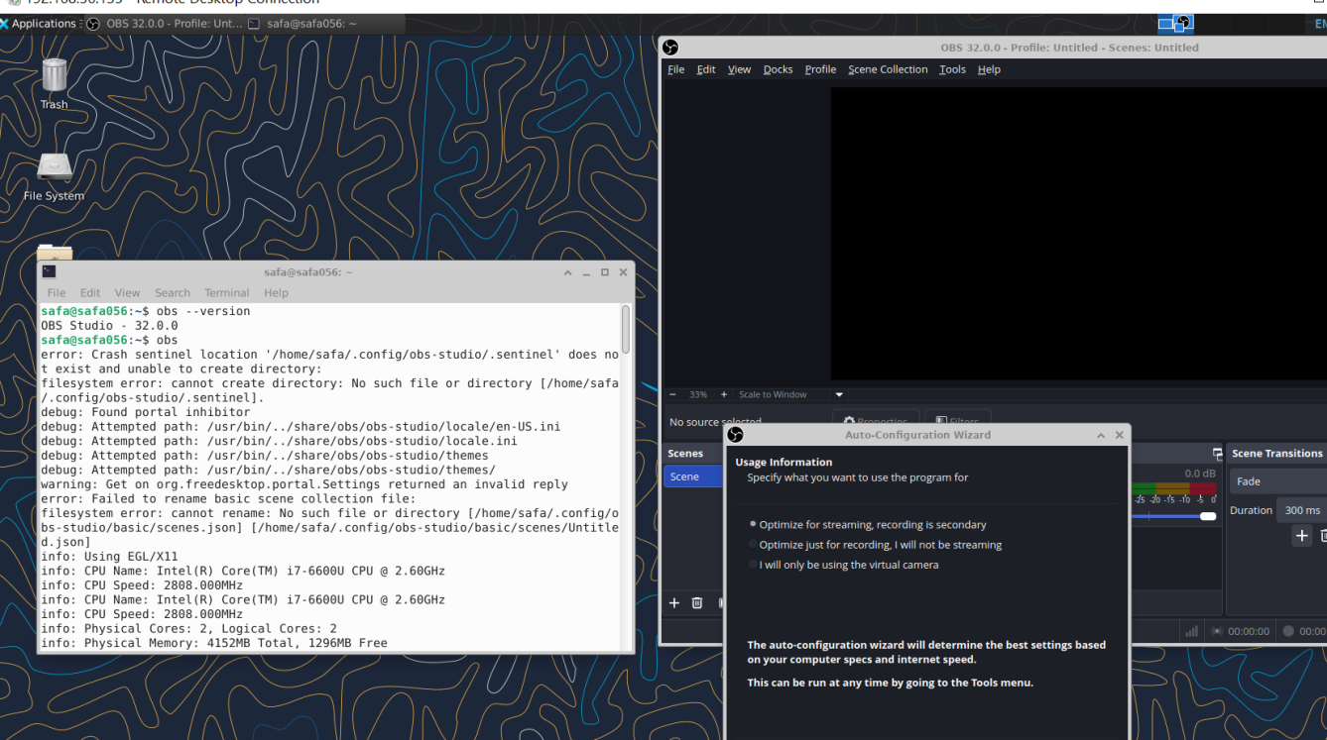

## Task 9 - Create a Kubernetes sample YAML using vim

* task9_vim_check.png

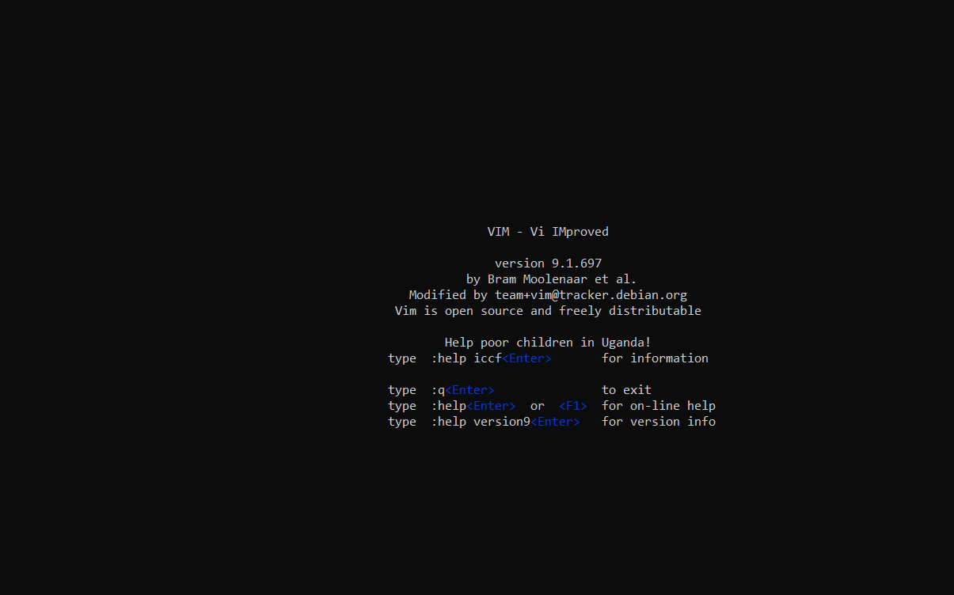

* task9_mkdir_cd.png

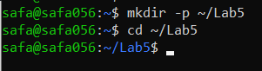

* task9_vim_edit.png

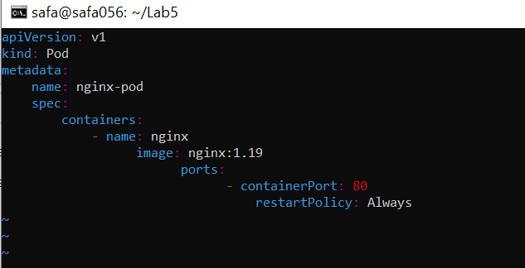

## Task 10 - Edit the Kubernetes YAML - add annotation, verify, then discard temporary change

* task10_verify_annotation.png

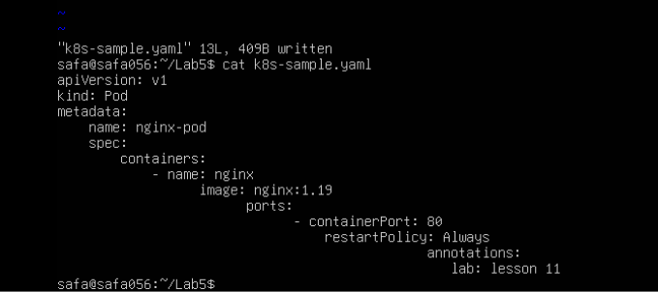

* task10_verify_entering_temp_data.png

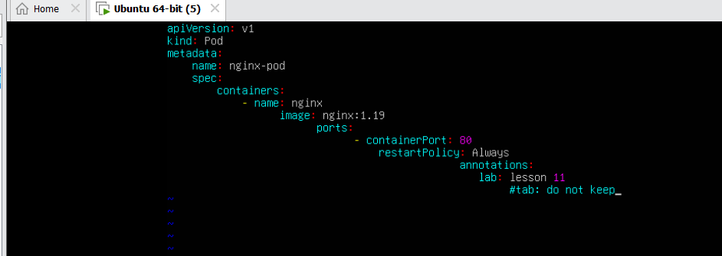

* task10_verify_no_temp_comment.png

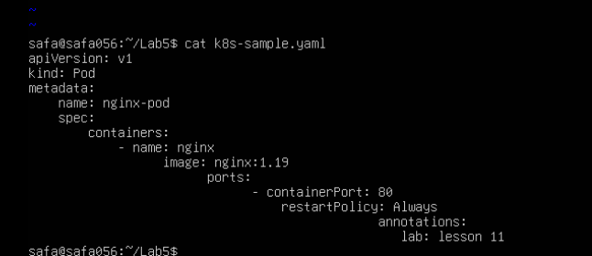

**Task 11 - Vim editing practice - delete, undo, numeric deletes, and navigation**

* task11_dd_delete_and_undo.png

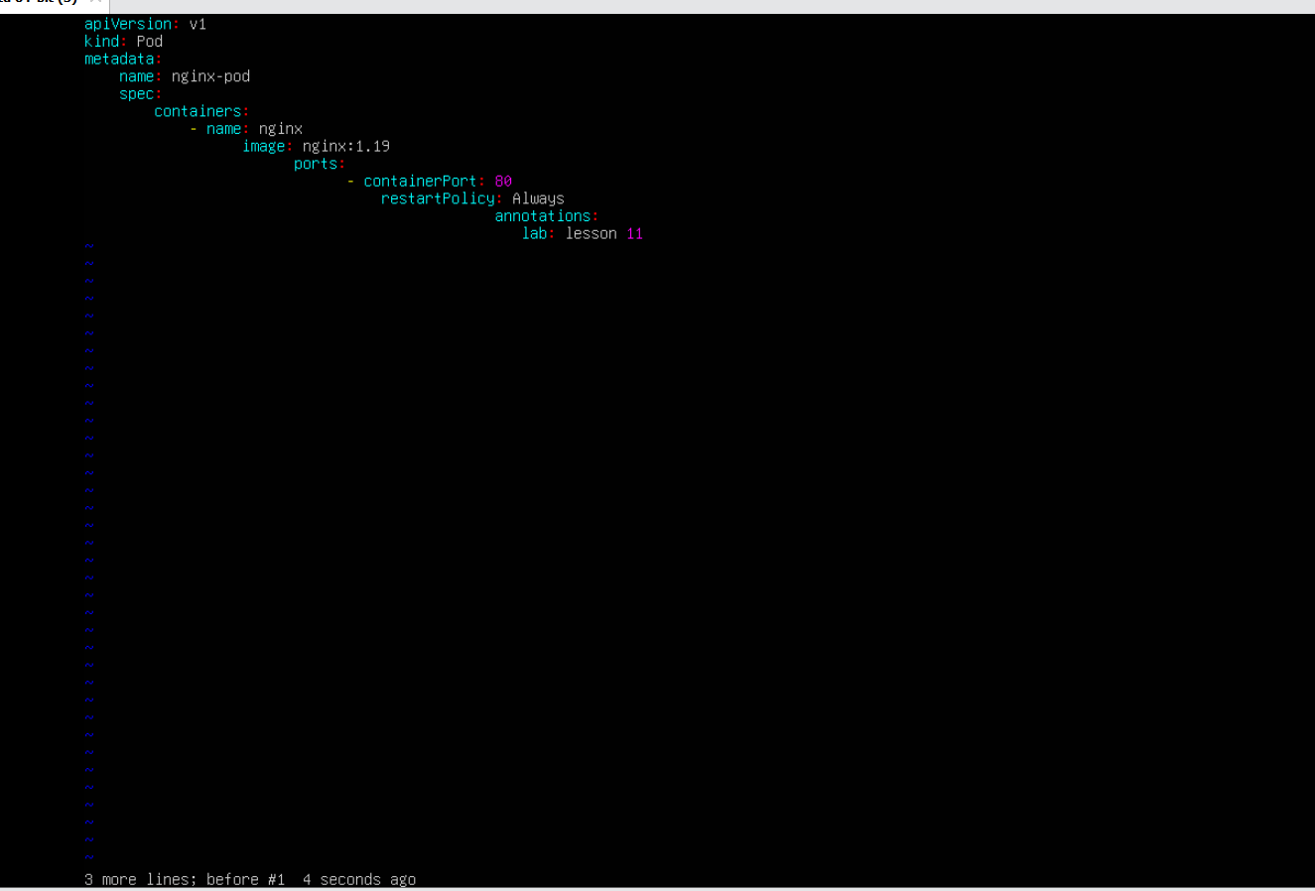

* task11_delete3_and_undo.png



* task11_line1.png

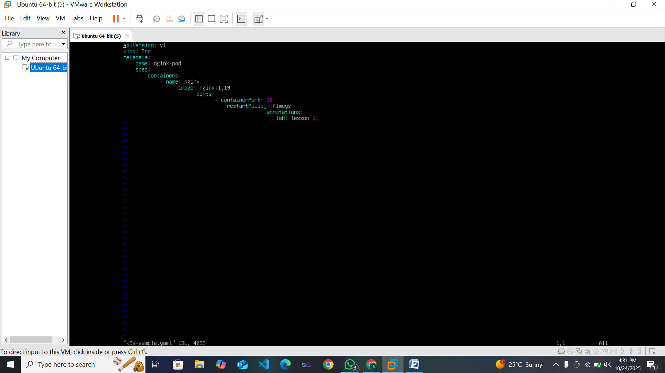

* task11_navigation.png

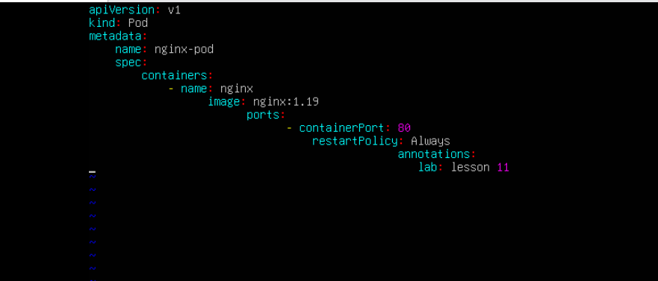

**Task 12 - Vim search, add matches, substitute, undo**

* task12_search_nginx.png

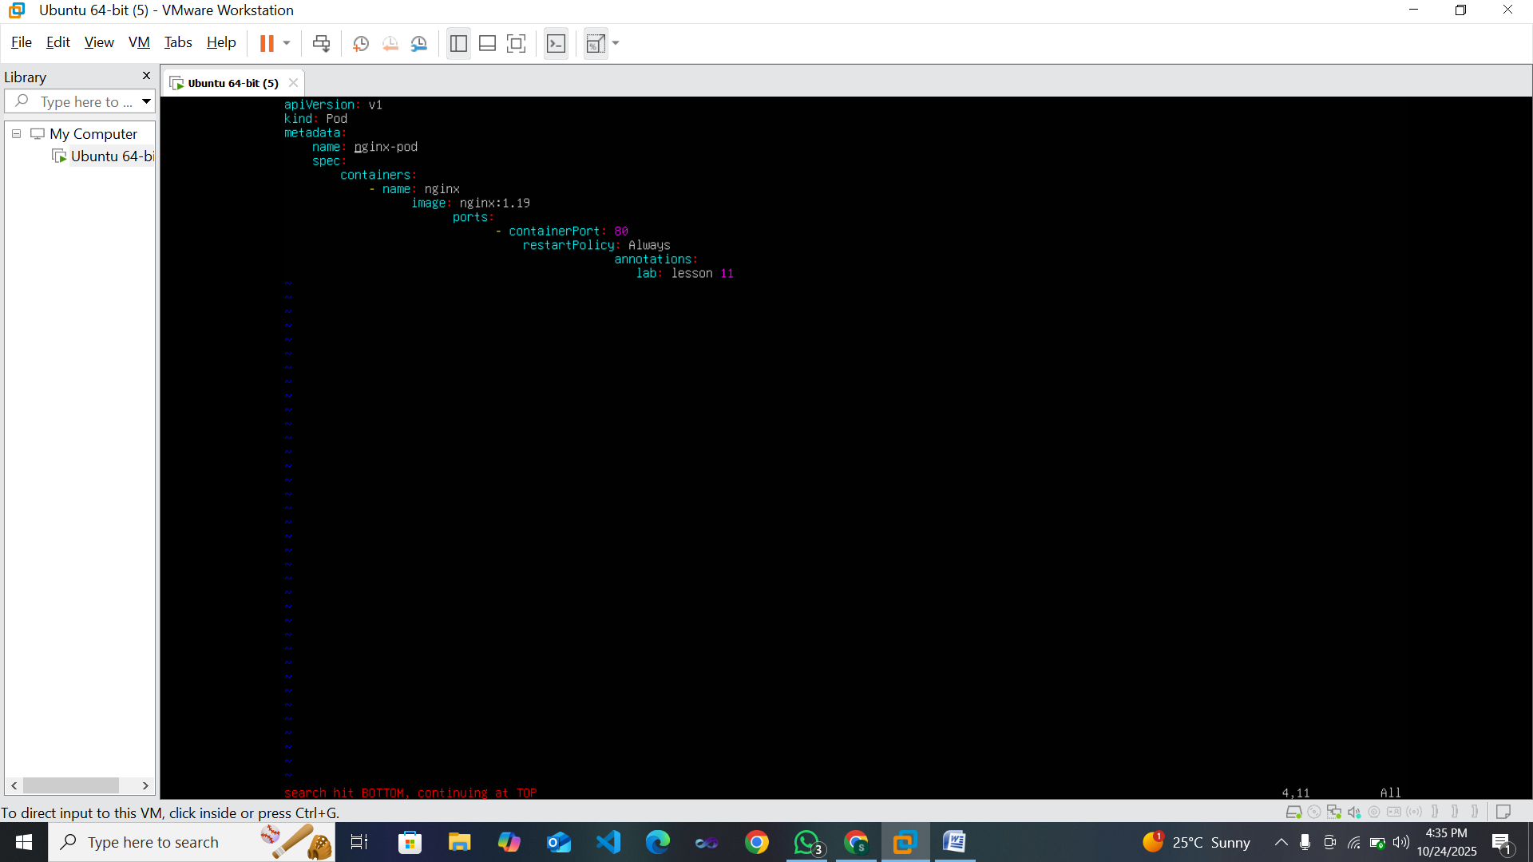

* task12_n_and_N_navigation.png



* task12_added_occurrences.png

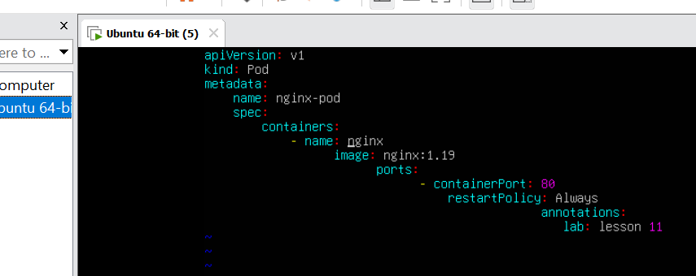

* task12_cycle_matches.png

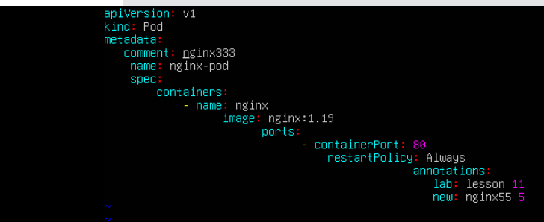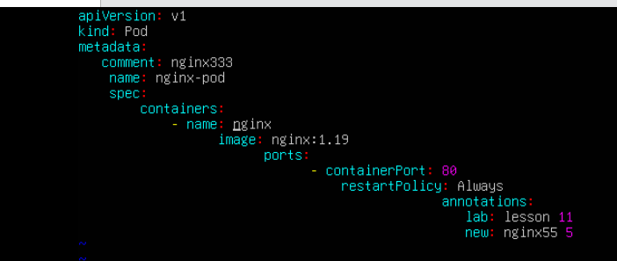

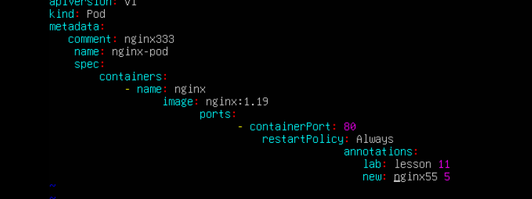

* task12_substitute_result.png

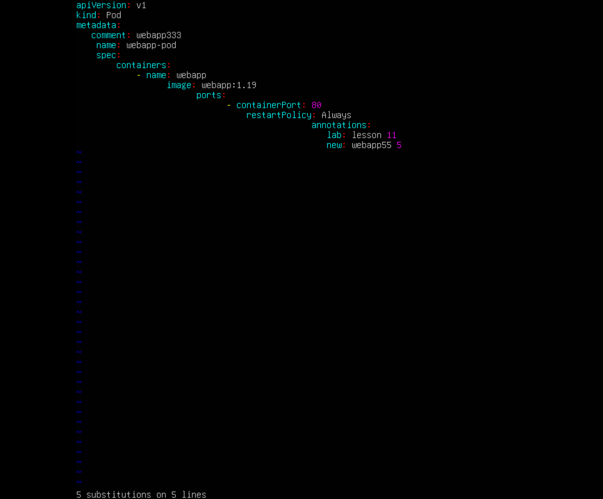

* task12_undo_and_quit.png

